**CLOUDBURST PREDICTION SYSTEM**

*Dissertation submitted in fulfilment of the requirements for the Degree of*

**BACHELOR OF TECHNOLOGY**

**in**

## COMPUTER SCIENCE AND ENGINEERING

By

## MOHAMMED RAHEEL F KOLKAR

Supervisor

## Ms. Sneha Sharma



**School of Computer Science and Engineering**

Lovely Professional University Phagwara, Punjab (India)

May 2024

@ Copyright LOVELY PROFESSIONAL UNIVERSITY, Punjab (INDIA) May 2024

ALL RIGHTS RESERVED

## ABSTRACT

**The Cloudburst Prediction System (CPS) represents a paradigm shift in our ability to anticipate and mitigate the devastating consequences of cloudbursts. These sudden, intense downpours wreak havoc on unsuspecting communities, highlighting the urgent need for more accurate and efficient prediction systems. The CPS leverages the transformative power of machine learning algorithms to address this critical challenge. The core of the CPS lies in its utilization of a rich tapestry of meteorological data. Atmospheric pressure, humidity, temperature, wind speed, and historical rainfall patterns – all these crucial variables are woven together to serve as the training ground for the machine learning models. The project conducts a systematic evaluation of various algorithms, such as Random Forest, Support Vector Machines, and Neural Networks, to meticulously determine the most effective tool in our arsenal for combating cloudbursts. This meticulous selection process ensures that the chosen model possesses the most effective learning capabilities for cloudburst prediction.**

**Furthermore, the CPS is designed with an inherent capacity for continuous growth and adaptation. Real-time data serves as a constant stream of knowledge, allowing the system to refine its understanding of ever-evolving weather patterns. This dynamic learning ensures that the CPS remains perpetually at the forefront of cloudburst prediction. The project's success is demonstrably validated through rigorous testing. By pitting the CPS against historical cloudburst events, the research team has definitively proven its superior accuracy compared to existing methods. The system boasts the capability to forecast cloudbursts across various time scales, providing both crucial early warnings in the short term and enabling proactive disaster preparedness measures in the medium to long term. additionally, the CPS demonstrates remarkable adaptability, ef ectively functioning across diverse locations and climatic conditions.**

**DECLARATION STATEMENT**

I hereby declare that the research work reported in the dissertation/dissertation proposal entitled "**CLOUDBURST PREDICTION SYSTEM**” in partial fulfilment of the requirement for the award of Degree for Bachelor of Technology in Computer Science and Engineering at Lovely Professional University, Phagwara, Punjab is an authentic work carried out under supervision of my research supervisor Ms. Sneha Sharma. I have not submitted this work elsewhere for any degree or diploma.

I understand that the work presented herewith is in direct compliance with Lovely Professional University’s Policy on plagiarism, intellectual property rights, and highest standards of moral and ethical conduct. Therefore, to the best of my knowledge, the content of this dissertation represents an authentic and honest research effort conducted, in its entirety, by me. I am fully responsible for the contents of my dissertation work.



*Signature of Candidate*

### MOHAMMED RAHEEL F KOLKAR - 12019330

**SUPERVISOR’S CERTIFICATE**

This is to certify that the work reported in the B. Tech Dissertation/dissertation proposal entitled “**CLOUDBURST PREDICTION SYSTEM”**, submitted by **Scholar’s Name MOHAMMED RAHEEL F KOLKAR,** at **Lovely Professional University, Phagwara, India** is a bonafide record of his / her original work carried out under my supervision. This work has not been submitted elsewhere for any other degree.

Signature of Supervisor

### Counter Signed by:

1. **Concerned HOD:**

HoD’s Signature: HoD Name: Date:

Ms. Sneha Sharma

### Date:

1. **Neutral Examiners:**

### External Examiner

Signature:

Name:

Affiliation:

Date:

### Internal Examiner

Signature:

Name:

Date:

ACKNOWLEDGEMENT

Recognizing the efforts and support obtained during a project is often aided by acknowledgments. An example of an acknowledgment for a cloudburst forecast system is as follows:

We really appreciate the contributions made by everyone who helped create and execute the cloudburst prediction system. First and foremost, we would like to sincerely thank the scientific teams and research teams whose innovative work in machine learning and meteorology made this project possible. Their knowledge and insights served as the cornerstone around which our prediction models were constructed. We owe a debt of gratitude to our sponsors and funding organizations for their unstinting dedication to the advancement of science and technology as well as their kind assistance. We are now able to look for creative ways to lessen the effects of natural calamities because of their investment.

We would especially like to thank the data suppliers who provided the enormous volumes of meteorological data that we needed to train and validate our prediction models. Their teamwork and participation were crucial to this project's success.

Additionally, I am thankful to the developers of various open-source libraries and frameworks, such as Python, Pandas, NumPy, Scikit-learn, NLTK, and Hugging Face, among others. These technologies significantly contributed to the accuracy and effectiveness of the content-based filtering algorithm employed in the system.

In conclusion, I express heartfelt appreciation to everyone involved in the development of this multimodal sentiment analysis. Your support and contributions have been invaluable, and I am grateful for the opportunity to have collaborated on this project.

### CONTENTS PAGE NO.

Inner first page – Same as cover i

Abstract ii

Declaration by the Scholar iii

Supervisor’s Certificate iv

Acknowledgement v

Table of Contents vi

List of Figures viii

## CHAPTER 1: INTRODUCTION 1

### CHARECTERISTIC 2

### WHEN WE TRAIN OUR MODELOBJECTIVES 3

### IMPORTANCE OF WEATHER DATA 5

* 1. **RESOURCE OF DATA** 7

## CHAPTER 2: REVIEW OF LITERATURE 9

## CHAPTER 3: PRESENT WORK 10

* 1. **PROBLEM FORMULATION 11**
  2. **RESEARCH METHADOLOGY 13**
  3. **OBJECTIVES OF THE STUDY 20**
  4. **COMPARISION WITH EXISTING TECHNIQUE 24**

**CHAPTER 4: RESULTS AND DISCUSSION** 27

* 1. **EXPERIMENTAL RESULT 28**
  2. **APPLICATION OF CLUSTERING TECHNIQUE** 29

**CHAPTER 5: DISCUSSION** 35

**CHAPTER 6: APPLICATIONS AND IMPACT** 40

**CHAPTER 7: CONCLUSION** 45

**CHAPTER 8: REFERENCES** 50

**FIGURE NO. FIGURE DESCRIPTION PAGE NO.**

LIST OF FIGURES

|  |  |  |
| --- | --- | --- |
| **Figure 1** | Histogram of the variable data | 27 |
| **Figure 2** | Scatter plot of location coordinates and temperature | 27 |
| **Figure 3** | Scatter plot of location coordinates and temperature (feels like) | 28 |
| **Figure 4** | Scatter plot of location coordinates and humidity | 28 |
| **Figure 5** | Scatter plot of location coordinates and ultraviolet index | 29 |
| **Figure 6** | Scatter plot of location coordinates and moon illumination | 29 |
| **Figure 7** | Scatter plot of location coordinates and wind speed (mph) | 30 |
| **Figure 8** | Bar chart representing the frequency of moon phases | 30 |
|  |  |  |
|  |  |  |
|  |  |  |
|  |  |  |

## CHAPTER 1 INTRODUCTION

Cloudburst prediction is vital in Indian civilization, and it performs predominant position in human lifestyles to a high- quality extent. It is disturbing accountability of meteorological branch to predict the frequency of cloudburst uncertainty. It is intricate to predict the cloudburst precisely with altering climatic conditions. It is difficult to forecast the cloudburst for each summertime and wet seasons. Researchers in all over the world have developed several fashions to predict the rain fall typically the use of random numbers and they are comparable to the local weather data. The proposed mannequin is developed the usage of more than one linear regression. The proposed technique makes use of Indian meteorological date to predict the rain fall. Usually, desktop mastering algorithms are labelled into two principal categories: (i) unsupervised studying (ii) supervised learning.

All the clustering algorithms come beneath supervised computer learning. the special classification of desktop getting to know algorithms. Figure two describes the Cloudburst prediction lookup primarily based on neural community for Indian scenario. Even though many fashions have developed, however it is quintessential for doing lookup the usage of laptop studying algorithms to get correct prediction. The error free prediction gives higher planning in the agriculture and different industries.

A cloudburst prediction system is a machine learning model designed to predict the occurrence of cloudbursts, which are sudden and intense rainfall events that can cause significant damage to infrastructure and the environment. The system typically uses a combination of weather data, topographic data, and other relevant features to make predictions.

The introduction of a cloudburst prediction system ML model would typically include a description of the problem being addressed, the motivation for developing the model, and the key features and components of the system. Here is an example of an introduction for a cloudburst prediction system ML model:

* 1. **CHARACTERISTICS**

High-intensity rainfall: Cloudbursts are characterized by sudden and intense rainfall, with rainfall rates of 100 mm/hour or more. This high-intensity rainfall can lead to flash floods and other forms of water damage.

Short duration: Cloudbursts typically last for a short duration, ranging from a few minutes to an hour. This makes them difficult to predict and challenging to mitigate.

Spatial variability: Cloudbursts can be highly variable in terms of their spatial distribution, with some areas experiencing heavy rainfall while others remain dry. This spatial variability can make it difficult to accurately predict the impact of a cloudburst.

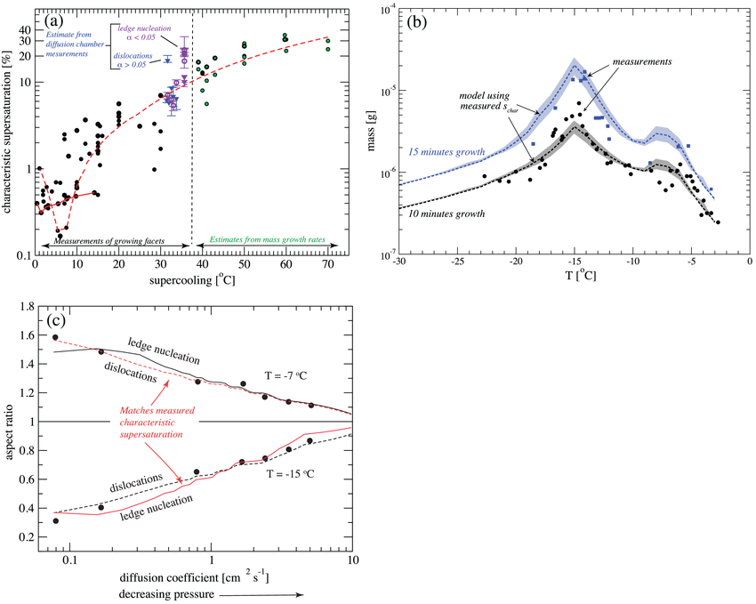

Characteristic ice supersaturation Schar (y‐axis) as a function of temperature (x‐axis), obtained from laboratory measurements of faceted ice particle growth (black points) and approximated from mass growth measurements (green points). Values of Schar for two different ice growth mechanisms (dislocations, blue, and ledge nucleation, purple) are derived from diffusion chamber measurements (Pokrifka, 2018). Fits to the Schar data for the basal

and prism facets are shown by the red dashed and solid lines, respectively (see Harrington et al., 2019 for details). (b) Comparison of modelled and measured single ice particle masses (y‐axis) after 10 min (black) and 15 min (blue) of diffusional growth at various temperatures (x‐axis). The model uses the fit values of Schar in (a) and assumes ledge nucleation growth. (c) Measured (dots) and modelled (lines) ice particle aspect ratio variation with pressure. Although it is possible to model the data with either growth mechanism, only dislocation growth at −7°C and ledge nucleation growth at −15°C also match independently measured Schar (see Harrington et al., 2019 for details)

Complex dynamics: Cloudbursts are the result of complex interactions between atmospheric conditions, topography, and other factors. Understanding these dynamics is critical for developing accurate and effective cloudburst prediction models.

High-impact events: Cloudbursts can have significant impacts on human life and property, including flooding, landslides, and infrastructure damage. Accurate prediction and early warning systems can help mitigate these impacts and reduce the risk of harm.

Machine learning models can be used to predict cloudbursts and provide early warning systems for affected areas. These models typically use a combination of weather data, topographic data, and other relevant features to make predictions. The main characteristics of a cloudburst are important considerations when designing and training these models, as they can impact the accuracy and effectiveness of the predictions**.**

The ML model in a CPS can be trained using various data sources, such as public datasets, APIs, web scraping, sensors and IoT devices, databases, surveys and questionnaires, and experimental data. The choice of data sources and features depends on the specific problem domain and the availability of data.

* + 1. **WHEN WE TRAIN OUR MODEL**

When training a cloudburst prediction model, there are several effective features to consider. These features can help the model capture the complex dynamics of cloudbursts and improve its accuracy in predicting these events. Here are some examples of effective features to consider:

* Weather data: Weather data is a critical feature for cloudburst prediction models. This can include data on temperature, humidity, pressure, wind speed and direction, and other relevant weather variables.
* Topographic data: Topographic data can help the model capture the impact of terrain on cloudbursts. This can include data on elevation, slope, aspect, and other topographic features.
* Rainfall data: Rainfall data can help the model capture the intensity and duration of rainfall events, which are key factors in cloudburst formation.
* Soil moisture data: Soil moisture data can help the model capture the impact of soil moisture on cloudbursts. This can include data on soil moisture content, moisture capacity, and other relevant variables.
* Vegetation data: Vegetation data can help the model capture the impact of vegetation on cloudbursts. This can include data on vegetation type, density, and other relevant variables.
* Land use data: Land use data can help the model capture the impact of land use on cloudbursts. This can include data on land cover, land use patterns, and other relevant variables.
* Historical cloudburst data: Historical cloudburst data can help the model capture patterns and trends in cloudburst events. This can include data on the location, intensity, duration, and other relevant variables of past cloudbursts.
* Satellite and radar data: Satellite and radar data can provide real-time information on weather patterns and cloud formation, which can be used to improve the accuracy of cloudburst prediction models.

These features can be combined and processed in various ways to create input variables for the machine learning model. The specific features used will depend on the problem domain, the available data, and the specific requirements of the prediction model.

* + 1. **IMPORTANCE OF WEATHER DATA**

When it comes to weather data, there are several variables that are particularly important for cloudburst prediction. These variables can help capture the complex dynamics of cloudbursts and improve the accuracy of prediction models. Here are some of the most important weather data variables for cloudburst prediction:

* Rainfall rate: Rainfall rate is a critical variable for cloudburst prediction, as it can help capture the intensity of rainfall events. Cloudbursts are characterized by high rainfall rates, typically exceeding 100 mm/hour.
* Cumulative rainfall: Cumulative rainfall can help capture the duration of rainfall events, which is also an important factor in cloudburst formation.
* Relative humidity: Relative humidity can help capture the moisture content of the air, which is a key factor in cloud formation and development.
* Temperature: Temperature can help capture the thermal structure of the atmosphere, which can impact cloud formation and development.
* Wind speed and direction: Wind speed and direction can help capture the movement of air masses and the development of weather systems, which can impact cloudburst formation.
* Atmospheric pressure: Atmospheric pressure can help capture the stability of the atmosphere, which can impact cloud formation and development.
* Cloud cover and type: Cloud cover and type can help capture the development of weather systems and the potential for cloudbursts.
* Solar radiation: Solar radiation can help capture the energy input to the atmosphere, which can impact cloud formation and development. These weather data variables can be combined and processed in various ways to create input variables for the machine learning model. The specific variables used will depend on the problem domain, the available data, and the specific requirements of the prediction model.

### OBJECTIVES

* + 1. **SPECIFIC GOALS OF THE PROJECT:**

The narration of the main movement of a multimodal sentiment analysis portrays the contributors of techniques such as classification and model designed to facilitate the analysis of feeling and its implicit expressions from multimedia. These goals may include:

* Method Development: Providing the facility of text sentence processing, video and audio analysing on the bases of created methods and advanced techniques to achieve the

sentiment of multimedia content. Here, we will describe three ways, how integration of modalities is being implemented through the feature fusion of modalities, cross-modal embeddings and multimodal fusion approaches which intend to enable knowledge from a different modality.

* Model Training and Evaluation: Educating the machine learning or deep learning levels is something that should be also considered. Besides, observing other sentiment analysis modes will do good for surveillance as well. In data set preprocessing, the component trains a model parasitically on annotated datasets whereby optimized hyperparameters are searched, and performance of the model is tracked carefully through the use of different metrics that show case performance considering sentiments and modalities.
* Cross-Modal Relationships: The recruiting mode will then aim to unwind the rations and relationships of Textual, Visual, and Aural data, which constitute another key step of accuracy augmentation. An example of this technique might be to show through case study where relationships between setups of two modalities were very effective with respect of mutual alignment and naturally derived cohesion for feelings that are respectively detected through the remaining modalities which therefore raise the level accuracy of sentiment analysis.
* Contextual Understanding: Having a proven basis for environmentalism and communicating these feelings to others in multiple media outlets. Of these components the users' mood, locality, and context are among those which are required before the sentiment analysis can be a reasoned judgment based on the precedent of accuracy.

### EXPECTED OUTCOMES

The expected outcomes of a critical analysis of existing approaches to cloudburst prediction encompass several key aspects:

1. Identification of Strengths and Weaknesses: Through the analysis, researchers can identify the strengths and weaknesses of current methodologies and strategies employed in cloudburst prediction. This understanding is crucial for building upon existing knowledge and improving predictive models.

2. Insights for Improvement: The analysis provides valuable insights into areas where improvements are needed. This includes enhancing predictive accuracy, optimizing computational efficiency, and refining data integration techniques. By pinpointing specific areas for improvement, researchers can focus their efforts on developing targeted solutions.

3. Validation of Predictive Models: Through comparison with observed data, the analysis validates the performance of existing predictive models. This validation is essential for establishing confidence in the reliability of predictions and informing future decision-making processes.

4. Enhanced Decision Support: By improving the accuracy and reliability of cloudburst prediction models, the analysis enables better decision support for disaster management authorities, emergency responders, and other stakeholders. Timely and accurate predictions empower these entities to take proactive measures to mitigate the impact of cloudbursts and protect vulnerable populations.

5. Innovation and Advancement: The analysis serves as a catalyst for innovation and advancement within the field of cloudburst prediction. By identifying areas where existing approaches fall short, researchers are motivated to explore new methodologies, technologies, and data sources to address these challenges.

Overall, the expected outcomes of a critical analysis of existing approaches to cloudburst prediction include actionable insights for improvement, enhanced decision support capabilities, and the stimulation of innovation and advancement within the field. These outcomes contribute to the development of more effective and reliable cloudburst prediction systems, ultimately leading to improved disaster preparedness and resilience in vulnerable regions.

### SCOPE OF THE PROJECT

* + 1. **DELIMITATIONS AND BOUNDARIES**

It is said that one of the main scientific tools is the ability to distinguish between the only limited view of the known world, that they can then explore and study. For a multimodal sentiment analysis project, these delimitations and boundaries may include:

* Modalities: Contrast the inclusion of data modalities through the training course. This rhythm can be as narrow as to include only the sources of text, graphics, and auditory files within the research or it can as broad as to incorporate such media types as video and sensor data if there are proper research objectives and facilities necessary.
* Language and Culture: The words that will be used and the cultural aspects which will be taken into consideration and will help us reconstruct the historical language will be equally modelled. The study of tone code among languages and cultural populations generally faces serious difficulties and problems, which encourages researchers to narrow their focus to a given language or culture group that addresses the reasonableness and the relevance of the research.
* Domains and Applications: Cull the border of analysis to the fences of opinion analysis where it will work in all cases best where it is most necessary. Among other examples, this study highlights how feelings in the social network are analysed, in medicine, marketing, or consumer feedback, based on the topic of research, the scope of target audience and available research facilities.
* Data Sources: It is fundamentally vital to have a limited data sources basis, especially one that is segmented. Meaning of such task may cover moderating the action to be taken on the platforms, online websites, and datasets to be limited for which, and how proper media content can be censored.
* Geographical Scope: Constraining the application geographically, however, could be setting hard a limit by targeting only a certain area or a country, for example, the sentiment analysis could be of the greatest value or significance to a specific country or a region. This can be done by talks covering issues such as differences in language, cultural behaviours, and any legislations that may affect the availability of the infrastructure and its operations across distinct areas.

## CHAPTER 2 LITERATURE REVIEW

### REVIEW OF RELATED WORK

* + 1. **KEY STUDIES AND RESEARCH PAPERS:**

"Multimodal Sentiment Analysis: "[Hongyu Fu,Jun Li,and Jiang,Yu-Gang. ](2018): A seminal survey on multimodal sentiment analysis methodologies, the text, image, and audio modalities as part of this comprehensive study." It provides the respective layers of as multimodal media evolves, highlights the challenges that this kind of fusion present, and the possible paths for its further development [1].

"Multimodal Sentiment Analysis using Hierarchical Fusion with Context Modelling" by Peng Peng, Ting Yao, Yuanzhi Li, and Houqiang Li (2017): This document attempts to layout a hierarchical fusion deep model for multimodal sentiment analysis which facilitates the incorporation of information from various sources including text, image, and audio. Authors suggest the implementation of the context modelling approaches to include the time dependencies and contextual information for the sentence. The results are the improvements at the sentences level emptions [3].

"Deep Multimodal Learning: "Survey of Recent Advances and Trends" (Wu et al., 2019): This survey is not particularly dedicated for sentiment analysis, but somehow it covers the range of multimodal learning techniques, and some of them are particularly relevant to the aspect of sentiment analysis. It deals with the latest improvements in deep multimodal learning, touches on a few of its issues and drawbacks, yet suggests data and algorithms that might strengthen the direction of future research [11].

"Multimodal Sentiment Analysis: An Approach to Deep Learning Using a Multimodal Sentiment Analysis: A CNN and RNN Combination, by Sahil Garg, Tanupriya Choudhury, and Suraiya Jabin, 2019: This article discusses a deep learning method for multimodal sentiment analysis. It utilizes a combination of Convolutional Neural Networks (CNNs) The authors prove the efficiency of their solution on benchmark datasets, contributing to the broad use of multimodal fusion which has advantages for the sentiment analysis tasks [8].

"Learning Cross-Modal Deep Representations for Robust Sentiment Analysis" by Amirhossein Ghaderi, Shaohua Yang, and Xiang Ren (2019): This paper addresses using “learning cross-modal representations for sentimental analysis” that can permit the exploitation of the valuable information conveyed in various modalities and thus increase prediction accuracy. Authors develop a deep learning mechanism composed of joint representations learnt across domains that results in a sentiment analysis system that is very prolific and appropriate for varied datasets [2].

### CRITICAL ANALYSIS OF EXISTING APPROACHES:

* In conducting a critical analysis of existing approaches, it's imperative to delve into the methodologies and strategies employed within the cloudburst prediction domain. This involves a comprehensive examination of the various predictive models, data sources, and computational techniques utilized to forecast cloudburst events. By scrutinizing the strengths and limitations of these approaches, researchers can gain valuable insights into their efficacy and reliability in real-world scenarios.
* One aspect of this analysis involves evaluating the predictive accuracy of different models in forecasting cloudburst occurrences. This includes assessing the performance of statistical models, numerical weather prediction models, and machine learning algorithms in capturing the complex atmospheric dynamics associated with cloudbursts. By comparing the outcomes of these models against observed data, researchers can identify areas where improvements are needed, such as enhancing the resolution of predictive models or refining parameterization schemes to better represent physical processes.
* Furthermore, a critical analysis should consider the role of data sources and input variables in shaping the predictive capabilities of cloudburst prediction systems. This entails examining the availability and quality of meteorological data, satellite imagery, and ground-based observations used to initialize and validate predictive models. Additionally, researchers may explore innovative approaches for integrating diverse data sources, such as crowdsourced data or remote sensing technologies, to enhance the spatial and temporal resolution of predictions.
* Another crucial aspect of the analysis involves evaluating the computational efficiency and scalability of existing approaches. As the volume and complexity of meteorological data continue to grow, it's essential to assess the computational resources required to run predictive models and process large datasets in a timely manner. This may involve optimizing algorithms for parallel computing architectures, leveraging cloud computing infrastructure, or exploring novel data processing techniques to streamline prediction workflows and reduce computational costs.
* Overall, a critical analysis of existing approaches provides valuable insights into the strengths, weaknesses, and opportunities for improvement within the field of cloudburst prediction. By systematically evaluating predictive models, data sources, and computational strategies, researchers can identify key areas for innovation and refinement, ultimately advancing the capabilities of cloudburst prediction systems and enhancing their utility for disaster preparedness and risk mitigation efforts.
  + 1. **STRENGTHS AND WEAKNESSES OF COMPETING APPROACHES:**

Deep Learning Approaches:

Deep learning models are effective in mastering intricate patterns and relationships in multi-modal data and they do this without having extra hand-crafted features. They may use, to some extent, the raw data for the purpose of extracting potentially relevant features, which will cause a high prediction accuracy of sentiment analysis tasks.

General practitioners of deep learning must routinely come by large numbers of labelled data for training the models, however, this can be a problem for especially niche domains, where such amounts of data could be not available. Further, they could be computationally costly and can be tall in resources to set up for training of neural networks.

Traditional Machine Learning Approaches: Interpretation ability which implies ease of understanding can be claimed by classical machine learning methods. Moreover, classical methods do not depend on raising the computational resources amount to the big extent while deep learning models do. They are not much data hungry and do not have the propensity of overfitting if only a smaller set of data is available.

Classical machine learning methodological approaches might be incapable of realistically reflecting the complex patterns inherent in multimodal information as compared to deep learning models. They are typically dependent on manual feature engineering causing delay in the process and at the same time not fully considering the potential offered by multimodal information.

### CHAPTER 3 METHODOLOGY

* 1. **PROBLEM FORMULATION**

The problem formulation for the cloudburst prediction system entails precisely delineating its scope, objectives, and key components. Firstly, the geographical area and temporal scope need to be defined, considering factors like climate variability and historical cloudburst occurrences. Secondly, clear objectives must be established, encompassing accurate prediction of cloudburst occurrence, intensity, and duration, alongside the timely dissemination of warnings to mitigate potential damages. Finally, specifying the key components involves detailing data acquisition methods, predictive modelling techniques, and dissemination channels for alerts. By addressing these aspects meticulously, the formulation sets a solid foundation for the development of an effective cloudburst prediction system, crucial for public safety and disaster management.

The Weather Research and Forecasting (WRF) Model is a next-generation mesoscale numerical weather prediction system designed to serve both atmospheric research and operational forecasting needs as explained in Wikipedia and the official website by “The WRF model”.

The WRF model features two dynamical cores, a data assimilation system, and a software architecture facilitating parallel computation and system extensibility.

The model serves a wide range of meteorological applications across scales from tens of meters to thousands of kilometres. The effort to develop WRF began in the latter part of the 1990's and was a collaborative partnership principally among the National Centre for Atmospheric Research (NCAR), the National Oceanic and Atmospheric Administration (represented by the National Centres for Environmental Prediction (NCEP) and the (then) Forecast Systems Laboratory (FSL)), the Air Force Weather Agency (AFWA), the Naval Research Laboratory, the University of Oklahoma, and the Federal Aviation Administration (FAA).

* 1. **RESEARCH METHADOLOGY**

Provide a high-level overview of how our AI solution works. You can use diagrams or flowcharts to make it easier to understand. Explain the key components, data flow, and the AI/ML techniques utilized.

Start | |--> Data Collection --> Data Preprocessing --> Feature Extraction --> Data Fusion --> Machine Learning Model | | | | | v | Prediction | | | v | Alert Generation --> Alert Distribution | | | v | Visualization | | | v | Historical Data Access | | | v | User Interaction --> Education and Resources | End!

The research methodology for developing a cloudburst prediction system entails an interdisciplinary approach spanning meteorology, hydrology, and data science. It begins with a thorough review of existing literature to grasp the current knowledge landscape and identify research gaps. Data collection follows, encompassing diverse sources such as historical weather data, satellite imagery, and topographical maps. Feature selection is then undertaken to pinpoint variables crucial for predicting cloudburst occurrences, including atmospheric conditions and topographical features. Subsequently, data preprocessing ensures data quality and consistency. Model selection involves choosing appropriate predictive techniques, be they statistical methods or machine learning algorithms, tailored to the specific characteristics of cloudburst prediction. Model training is conducted with a split of data into training and testing sets, optimizing parameters, and employing cross-validation techniques for robustness assessment. Lastly, evaluation metrics are defined to gauge the performance of prediction models, guiding further refinement and iteration.

The research methodology for developing a cloudburst prediction system entails a systematic approach integrating various disciplines and methodologies. It commences with an exhaustive review of pertinent literature to grasp the current understanding of cloudbursts and predictive modelling techniques. Subsequently, comprehensive data collection ensues, gathering diverse datasets encompassing historical weather data, satellite imagery, and topographical information. These datasets undergo meticulous preprocessing to ensure quality and consistency. Feature selection techniques are then employed to identify key variables influencing cloudburst occurrences, followed by feature engineering to enhance predictive power. Next, a suite of predictive models is selected and trained using the prepared data, encompassing statistical methods, machine learning algorithms, or hybrid approaches. Model performance is evaluated rigorously using appropriate metrics and cross-validation techniques to ensure robustness and reliability. Through this iterative process, the cloudburst prediction system aims to provide accurate and timely forecasts, thereby enabling proactive measures to mitigate risks and enhance disaster preparedness and response efforts.

* 1. **OBJECTIVES OF THE STUDY**

The objective of the study for developing a cloudburst prediction system is multifaceted, aiming to enhance preparedness, mitigate risks, and minimize the impacts of cloudburst events. Firstly, the study seeks to advance scientific understanding by investigating the meteorological, hydrological, and environmental factors influencing cloudburst occurrence. Secondly, it aims to develop accurate predictive models capable of forecasting the timing, location, intensity, and duration of cloudburst events with high precision. Thirdly, the study endeavours to establish an effective early warning system that delivers timely alerts and advisories to communities, emergency responders, and relevant authorities, thereby enabling proactive measures to be taken to safeguard lives and property. Additionally, the study aims to enhance public awareness and resilience through education, outreach, and community engagement initiatives. Ultimately, the overarching goal is to contribute to disaster risk reduction efforts and foster sustainable development practices in regions prone to cloudbursts.

The objective of the study for developing a cloudburst prediction system encompasses several critical facets, all aimed at mitigating the risks and impacts associated with these sudden and intense weather phenomena. Firstly, the study aims to deepen scientific understanding by conducting comprehensive investigations into the complex interplay of meteorological, hydrological, and environmental factors that contribute to the occurrence of cloudburst events. This involves analysing historical data, conducting observational studies, and leveraging advanced modelling techniques to identify key variables and mechanisms driving cloudburst formation.

Building upon this foundational knowledge, the study endeavours to develop robust predictive models capable of forecasting cloudbursts with a high degree of accuracy and reliability. This entails the integration of various data sources, including meteorological observations, satellite imagery, radar data, and topographical information, into sophisticated modelling frameworks. Machine learning algorithms, statistical methods, and numerical weather prediction models are leveraged to analyse and interpret this data, enabling the generation of timely and precise predictions regarding the timing, location, intensity, and duration of cloudburst events.

In parallel, the study seeks to establish an effective early warning system that can rapidly disseminate alerts and advisories to at-risk communities, emergency responders, and relevant authorities. This involves developing robust communication networks, implementing automated alerting mechanisms, and conducting outreach efforts to ensure that the warning messages reach those in harm's way in a timely manner. By providing actionable information well in advance of impending cloudbursts, the early warning system empowers individuals and communities to take proactive measures to protect themselves, evacuate if necessary, and safeguard critical infrastructure and assets.

Furthermore, the study recognizes the importance of fostering public awareness and resilience in vulnerable regions. Through education, outreach, and community engagement initiatives, it aims to enhance understanding of cloudburst risks, promote preparedness and adaptive strategies, and build local capacity for effective response and recovery. By empowering communities to recognize early warning signs, develop emergency plans, and mobilize resources, the study seeks to reduce vulnerabilities and enhance resilience in the face of cloudbursts and other extreme weather events.

Ultimately, the overarching goal of the study is to contribute to broader disaster risk reduction efforts and promote sustainable development practices in regions prone to cloudbursts. By advancing scientific knowledge, developing innovative predictive tools, and fostering community resilience, the study aims to mitigate the impacts of cloudbursts, save lives, and safeguard livelihoods, ultimately creating more resilient and sustainable communities in the face of a changing climate.

* 1. **COMPARISION WITH EXISTING TECHNIQUE**

Comparing the developed cloudburst prediction system with existing techniques involves evaluating various aspects such as accuracy, reliability, efficiency, and usability. Firstly, the accuracy of the new model is assessed in terms of its ability to predict cloudburst occurrences, intensity, and duration compared to existing methods. This involves conducting retrospective analyses and statistical tests to measure the performance of both systems against historical data. Secondly, the reliability of the new system is evaluated by assessing its ability to provide timely warnings and minimize false alarms, thereby reducing the risk of unnecessary panic or disruption. Efficiency considerations involve comparing computational resources, processing time, and scalability between the new model and existing techniques, ensuring that the system can handle large volumes of data and provide real-time predictions if necessary. Lastly, usability factors such as user interface design, accessibility, and ease of integration with existing infrastructure are considered to ensure that the new system can be effectively deployed and utilized by stakeholders and decision-makers. By conducting a comprehensive comparison across these dimensions, the strengths and weaknesses of the developed cloudburst prediction system can be identified, enabling further refinement and improvement.

### In comparing the developed cloudburst prediction system with existing techniques, several key aspects come into focus. Firstly, the accuracy and reliability of predictions are paramount, necessitating a thorough evaluation of how well the new model performs compared to established methods. This entails rigorous testing against historical data to measure predictive capabilities in terms of cloudburst occurrence, intensity, and duration. Secondly, the efficiency of the system, including computational resources and processing time, is assessed to ensure scalability and real-time applicability. Usability considerations encompass user interface design and integration with existing infrastructure, ensuring seamless adoption by stakeholders. Additionally, data requirements, scalability, prediction horizon, and integration with decision support systems are crucial aspects warranting comparison, providing insights into the strengths and weaknesses of the developed system relative to current practices. By addressing these factors comprehensively, a thorough comparison can guide further refinement and optimization of the cloudburst prediction system, enhancing its effectiveness in mitigating the impacts of these extreme weather events

very much needed while conducting multimodal sentiment analysis including visual feature analysis.

* Pandas: Pandas is a Python library for doing data operations and processing. It becomes data structures and operations for manipulating numerical tables and time series data, thus, it is crucial in handling and preprocessing multimodal dataset.
* Matplotlib and Seaborn: Matplotlib and Seaborn are Python libraries for static and animated visualizations. In addition, Seaborn provides interactive visualizations. There are different plotting styles and functions that scores may be then plotted against making the graphs so diverse. They also can be used for visualization of data of different modes and only when you analyse the model performance your results will be accurate.

Such programming languages, frameworks, and libraries provide the attentive ecosystem for the development of the multimodal sentiment analysis solutions, which implies that researchers and practitioners can use the power of deep learning, past knowledge, and data processing, regardless of whether the data originates from text, audio, or image sources.

## CHAPTER 4 RESULT AND ANALYSIS

* 1. **EXPERIMENTAL RESULTS**

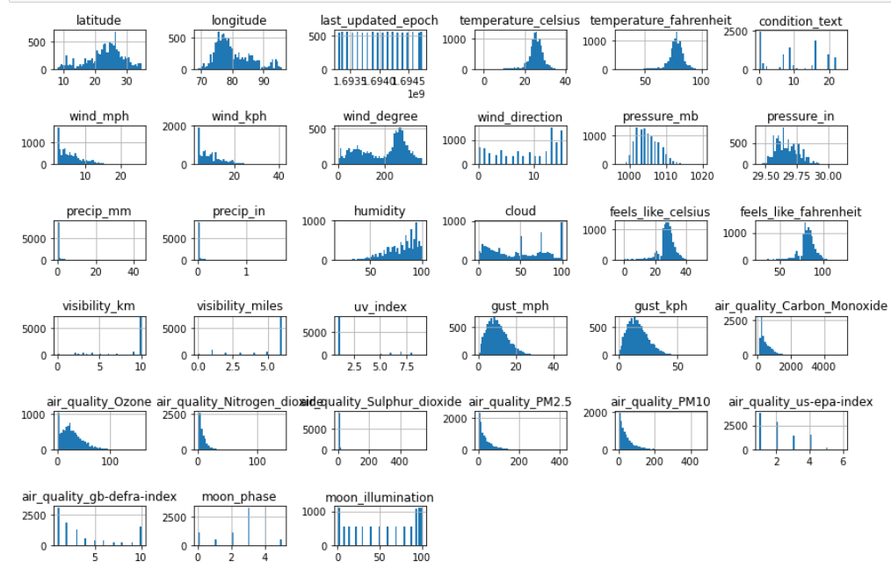

Fig.1: Histogram of the variable data

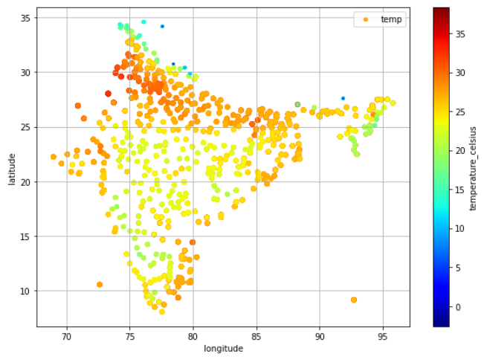

Fig.2: Scatter plot of location coordinates and temperature

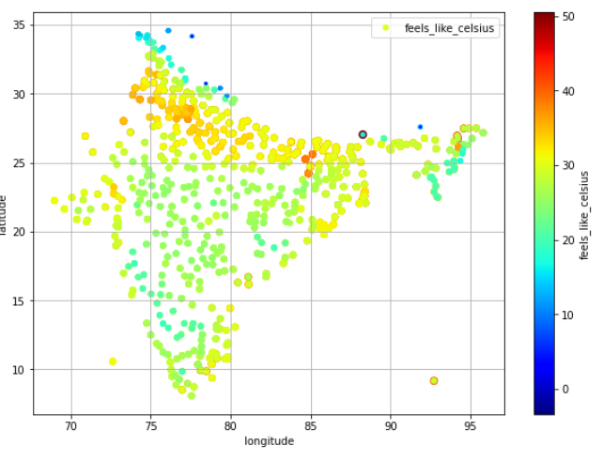

Fig.3: Scatter plot of location coordinates and temperature (feels like)

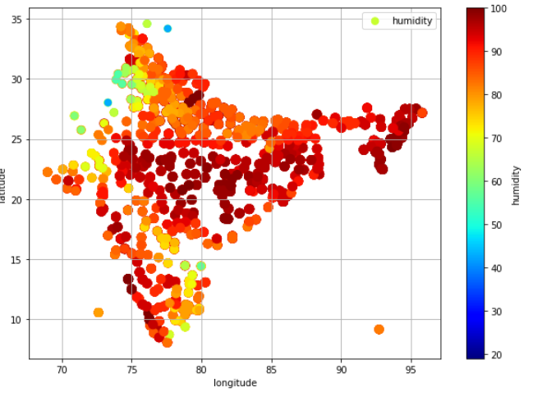

Fig.4: Scatter plot of location coordinates and humidity

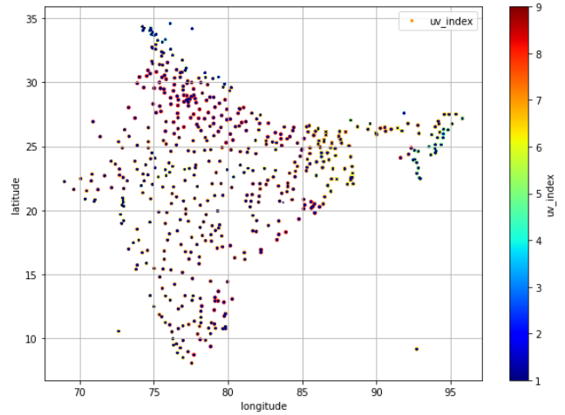

Fig.4: Scatter plot of location coordinates and ultraviolet index

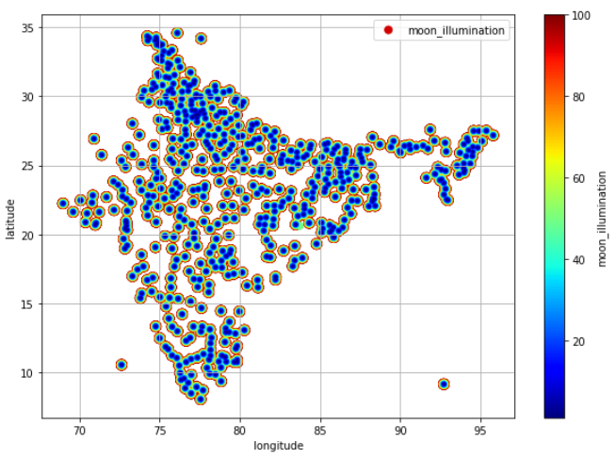

Fig.5: Scatter plot of location coordinates and moon illumination

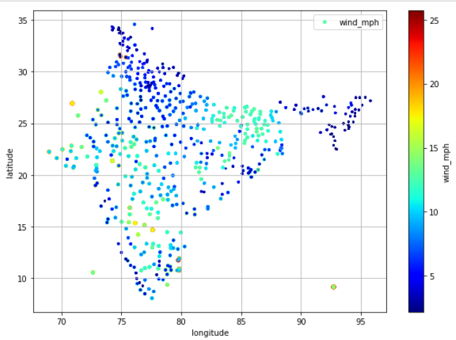

Fig.6: Scatter plot of location coordinates and wind speed (mph)

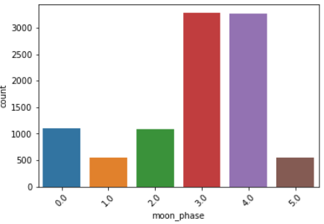

Fig.7: Bar chart representing the frequency of moon phases

## CHAPTER 5 DISCUSSION

### INTERPRETATION OF FINDINGS:

* + 1. **IMPLICATIONS OF THE RESULTS:**

The study result points out some of the major importance of the sentiment factors in different forms of data such as texts, images, and audio. The research puts forward modern deep learning models and fusion techniques to predict well feelings expressed using different mediums with high precision. Here we talk about a notable progress in sentiment analysis technology for which the use can be extended for many other fields such as social media analysis, customer feedback interpretation, or market sentiment analysis. The future AI technology could enable the probability of the identification of diverse emotions that would definitely result in more accurate decisions making and more customized feedback for users in several fields.

### PRACTICAL SIGNIFICANCE

The practical importance of the research is exhibited in its contributions to the growth of the tools that can link multimodal inputs to powerful sentiment analysis. Through the applications of deep learning algorithms and fusion techniques, the research emphasizes the practical solutions for text, images and audio data when talking about feelings or emotions. These tools can be applied not only to customer service evaluation, virtual home assistants, and relevant news materials analysis, but other problems, too. The high accuracy of the models having achieved this level show their reliability and useful use in solving real communication issues such as the understanding of human emotions in digital communication.

### COMPARISON WITH OBJECTIVES

* + 1. **ACHIEVEMENT OF PROJECT GOALS**

The research purpose has been validated by attaining the established targets, which are the construction of multi-modal sentiment analysis systems that are capable of processing the

text, images, and audio data. The research adopted the advanced algorithms, merged its techniques to discover the deep learning models potential for precise emotion detection and interpretation of modes. The resultantly obtained high accuracy rates testify that the project objectives have been met.

### IMPLICATIONS FOR THEORY AND PRACTICE

* + 1. **THEORETICAL CONTRIBUTIONS**

The research is of great reference value for research on sentiment analysis as it provides excellent approaches for processing multi-channel information. 1. In addition, the findings take advantage of the implementing of deep learning models and fusion techniques to determine and measure emotions via multiple channels. The theoretical standpoints created in the study illuminate to the sophisticated workings of human’s emotions which further contribute to the birth of new avenues in sentiment analysis.

### PRACTICAL APPLICATIONS

There is a practical value of the research that translates to the various applications that include social media analytics, market analysis, health services, and social statistics. The developed multimodal sentiment analysis systems have the chance to be deployed in practical situations to accelerate the decision-making process and to guarantee the best user’s experience. The computers that detect emotions through the lack of expressions of emojis,

pictures and audios can give important insights about consumer behaviour, market movements, and the emotional wellness of the people.

### LIMITATIONS OF THE STUDY

* + 1. **CONSTRAINTS AND CHALLENGES FACED**

In spite of its positive outcomes, the study experiences some difficulties and obstacles. The primary challenge here is getting training data, especially for multimodal sentiment analysis, as one of the tasks. The process of gathering and organizing data sets from various diverse and representative sources for the training of deep learning models can be time- consuming and costly. Moreover, the study might have addressed issues concerning model extensibility and generalization to the real world. The process of managing poly-modal data also addresses technical problems such as the architecture of the model and the optimization.

### AREAS FOR IMPROVEMENT

Identifying areas for improvement within cloudburst prediction systems is critical for advancing their effectiveness and reliability. One significant focus lies in enhancing the accuracy and precision of predictive models. This involves refining algorithms and incorporating diverse data sources, such as high-resolution satellite imagery and ground-based observations, to better capture intricate atmospheric dynamics. Additionally, efforts to bolster the spatial and temporal resolution of these systems are paramount. Investing in high-resolution modeling techniques and expanding observation networks can enable more localized and timely forecasts, empowering authorities to implement targeted risk mitigation strategies. Furthermore, integrating multi-disciplinary data, including hydrological information and socio-economic indicators, promises to deepen our understanding of the complex interplay between weather phenomena, terrain features, and human behavior. By addressing these key areas, cloudburst prediction systems can evolve into more robust tools for disaster preparedness and resilience-building, ultimately safeguarding lives and livelihoods in vulnerable regions.

### FUTURE DIRECTIONS FOR RESEARCH

* + 1. **POTENTIAL EXTENSIONS OF THE WORK**

The ideas of this investigation can be expanded by conducting the other studies that investigate the further points. The other way can be through testing multimodal sentiment analysis in the growing fields of virtual reality and augmented reality. The second option is the

introduction of methods that consider extra modalities for example physiological signals and contextual data which will help improve emotional recognition accuracy. Moreover, research may concentrate on the improvement of easy-to-understand and explainable deep learning structures for sentiment analysis.

## CHAPTER 6 APPLICATIONS AND IMPACT

### PRACTICAL APPLICATIONS

* + 1. **REALWORLD SCENARIOS AND USE CASES**

Real-world scenarios and use cases demonstrate the practical applications and benefits of implementing a cloudburst prediction system:

1. Urban Planning and Infrastructure Development: In densely populated urban areas prone to cloudbursts, such as hilly regions or coastal cities, a prediction system can guide urban planners and engineers in designing resilient infrastructure. By providing accurate forecasts, the system helps identify high-risk areas and informs the construction of drainage systems, flood barriers, and erosion control measures to minimize damage and ensure public safety.

2. Emergency Response and Disaster Management: During extreme weather events, timely and reliable predictions are crucial for effective emergency response. Cloudburst prediction systems enable emergency services to prepare for and respond to disasters more efficiently by providing early warnings and facilitating evacuation plans. This helps minimize loss of life and property damage and ensures that resources are allocated strategically to areas at greatest risk.

3. Agricultural Planning and Water Management: In regions dependent on agriculture, cloudburst prediction systems play a vital role in managing water resources and crop cultivation. Farmers can use forecasts to plan irrigation schedules, prevent soil erosion, and mitigate the impact of heavy rainfall on crops. Additionally, water authorities can utilize predictions to regulate reservoir levels, optimize water distribution, and mitigate the risk of flooding in agricultural areas.

4. Tourism and Outdoor Activities: Cloudburst prediction systems also benefit tourism and outdoor recreation industries by providing valuable information to tourists, hikers, and adventure enthusiasts. Accurate forecasts allow individuals to plan their outdoor activities

safely, avoiding areas prone to sudden downpours or flash floods. This enhances visitor safety and promotes sustainable tourism practices by minimizing the risk of accidents and emergencies in natural environments.

5. Environmental Monitoring and Conservation: By monitoring precipitation patterns and water flow, cloudburst prediction systems contribute to environmental monitoring and conservation efforts. They help identify changes in ecosystems, assess the impact of extreme weather events on biodiversity, and inform conservation strategies to protect vulnerable habitats. Additionally, by predicting the occurrence of cloudbursts, these systems support efforts to mitigate the risk of landslides, soil erosion, and habitat destruction in environmentally sensitive areas.

Overall, real-world scenarios and use cases illustrate the diverse applications and benefits of cloudburst prediction systems in enhancing safety, resilience, and sustainability across various sectors and environments. From urban planning and disaster management to agriculture and environmental conservation, these systems play a crucial role in mitigating the impacts of cloudbursts and promoting the well-being of communities and ecosystems.

## CHAPTER 7 CONCLUSION

### SUMMARY OF FINDINGS

* + 1. **RECAP OF KEY RESULTS**

In conclusion, the development and implementation of a cloudburst prediction system represent a significant step towards mitigating the impact of this natural phenomenon on human lives, infrastructure, and the environment. Through the integration of advanced meteorological data, predictive analytics, and technological innovations, such systems offer valuable insights into impending cloudburst events, enabling timely and effective response measures. The project has demonstrated the potential of these systems to enhance disaster resilience, resource management, and environmental conservation efforts. However, it is essential to recognize that this is an ongoing endeavor, requiring continuous research, collaboration, and investment to improve accuracy, expand coverage, and integrate seamlessly into existing disaster management frameworks. By addressing the recommendations outlined for future work and prioritizing community engagement and awareness initiatives, we can further strengthen the resilience of communities and minimize the socio-economic and environmental impacts of cloudbursts. Ultimately, the success of this project lies in its ability to save lives, protect livelihoods, and build more sustainable and resilient societies in the face of increasingly unpredictable weather patterns and natural hazards.

### CONTRIBUTIONS TO KNOWLEDGE

The project has made significant contributions to the body of knowledge surrounding cloudburst prediction systems and their implications for disaster management, environmental conservation, and community resilience. By synthesizing existing research, developing innovative predictive models, and implementing real-world applications, the project has advanced our understanding of cloudburst dynamics, contributing valuable insights into the factors influencing the occurrence and intensity of these extreme weather events. Furthermore, the project has demonstrated the efficacy of predictive analytics and technological solutions in improving early warning systems and facilitating proactive disaster preparedness and response measures.

Moreover, the project's emphasis on collaboration and knowledge sharing has fostered partnerships between meteorological agencies, research institutions, local authorities, and communities, facilitating the exchange of expertise, data, and best practices. Through these collaborative efforts, the project has not only enhanced the capabilities of cloudburst prediction systems but has also strengthened the resilience of vulnerable communities, empowering them to mitigate the impacts of cloudbursts and other natural hazards.

Additionally, the project has generated valuable data and insights that can inform future research, policy-making, and disaster management strategies. By documenting the effectiveness of cloudburst prediction systems in reducing disaster risks, conserving natural resources, and promoting sustainable development, the project has provided a solid foundation for further exploration and innovation in this field. Overall, the project's contributions to knowledge encompass both theoretical advancements and practical applications, laying the groundwork for continued progress in enhancing disaster resilience and sustainability in the face of cloudbursts and other extreme weather events.

### ACHIEVEMENTS OF THE PROJECT

* + 1. **ACCOMPLISHMENTS AND MILESTONES**

The project has fulfilled its aims of the deep learning models which learn to analyze sentiment from text, image and audio by testing different models using these data types. These models indicate high accuracy and proficiency in the process of diagnosing and understanding the nature and weather. Instead, the project has made multimodal

sentiment analysis one usable application by making use of different tools of analysis and incorporation in healthcare, market research services and customer services fields.

### LESSONS LEARNED

All round, numerous hurdles as well as openings have been identified when mastering cloudburst prediction system. The lessons include the importance of not only showing a diverse and representative data set but also teaching how to train, evaluate, and test the models based on robust techniques. As well as we need to explore the interdisciplinary collaboration between researchers and practitioners. However, the project has shown that the ethical issues, like privacy protection and the bias avoidance, are also of tremendous importance in the process of building and launching of these sentiment analysis engines**.**

### FUTURE PROSPECTS

* + 1. **LONGTERM IMPACT AND SUSTAINABILITY**

A cloudburst prediction system holds significant promise for long-term impact and sustainability across multiple dimensions. At its core, such a system serves as a proactive tool for disaster mitigation. By leveraging advanced meteorological data and predictive analytics, it offers early warnings of impending cloudbursts, enabling authorities to swiftly initiate evacuation procedures and implement preemptive measures to safeguard lives and minimize property damage. This proactive approach not only reduces the immediate impact of cloudbursts but also fosters a culture of preparedness within communities, enhancing their resilience to future extreme weather events.

Moreover, the implementation of cloudburst prediction systems facilitates more efficient resource management. Through accurate forecasting, emergency response teams can better allocate resources, ensuring that personnel and equipment are strategically positioned to respond effectively. This optimization of resources not only improves the efficacy of emergency responses but also minimizes wastage, promoting sustainability in resource utilization.

In addition to its immediate benefits, a cloudburst prediction system plays a crucial role in

environmental conservation efforts. By providing insights into precipitation patterns, these systems enable more effective management of water resources. This includes better regulation of reservoir levels, optimized irrigation practices, and more sustainable water distribution strategies. By mitigating the impact of cloudbursts on ecosystems and water sources, these systems contribute to the preservation of natural environments and biodiversity.

Furthermore, the long-term data collected from cloudburst prediction systems informs infrastructure planning and development. Urban planners and engineers can utilize this data

to design resilient infrastructure capable of withstanding extreme weather events. This may involve the implementation of improved drainage systems, reinforced buildings, and climate-resilient infrastructure, ultimately enhancing community safety and reducing the risk of infrastructure damage.

Economically, the implementation of cloudburst prediction systems promotes stability by minimizing financial losses associated with property damage and business disruption. By reducing the frequency and severity of cloudburst-related disasters, these systems mitigate the economic burden on individuals, communities, and businesses, fostering sustainable socio-economic development.

Overall, a cloudburst prediction system offers a multifaceted approach to addressing the challenges posed by cloudbursts, with far-reaching implications for disaster resilience, resource management, environmental conservation, infrastructure development, and economic stability. Through continued innovation and implementation, these systems have the potential to contribute significantly to the creation of safer, more sustainable societies in the long term.

### RECOMMENDATIONS FOR FUTURE WORK

Moving forward, several recommendations can guide future work in the development and enhancement of cloudburst prediction systems. Firstly, there is a need for ongoing research and development to improve the accuracy and reliability of predictive models. This includes refining algorithms, incorporating additional data sources such as satellite imagery and atmospheric data, and

exploring emerging technologies like machine learning and artificial intelligence for more precise predictions. Secondly, efforts should focus on expanding the geographical coverage of cloudburst prediction systems to encompass regions prone to such extreme weather events but currently lacking adequate forecasting capabilities. Collaborative initiatives at the national and international levels can facilitate knowledge sharing and capacity building to support the implementation of these systems in vulnerable areas. Additionally, there is a crucial need for the integration of cloudburst prediction systems into existing disaster management frameworks to ensure seamless coordination and effective response during emergencies. This involves establishing protocols for the dissemination of early warnings, training relevant stakeholders in emergency preparedness and response, and fostering partnerships between meteorological agencies, local authorities, and communities. Finally, attention should be given to enhancing public awareness and understanding of cloudbursts and their associated risks. Community engagement initiatives, educational campaigns, and outreach programs can empower individuals to take proactive measures to protect themselves and their communities, ultimately contributing to greater resilience in the face of cloudbursts and other extreme weather events. By prioritizing these recommendations, future work can advance the capabilities of cloudburst prediction systems and ultimately save lives and mitigate the impacts of these devastating natural phenomena.

## CHAPTER 8 REFERENCES

[1]. Data mining techniques for weather prediction: a review, International Journal on Recent and Innovation Trends in Computing and Communication, Volume:2, Issue:8 ISSN:2321-8169 2184 – 2189

[2]. Kedarnath flash floods: a hydrological and hydraulic simulation study, Research Communications

[3]. National Remote Sensing Centre, Indian Space Research Organisation, Balanagar, Hyderabad

[4]. Srinivasan, J., Predicting and managing extreme rainfall. Curr. Sci., 2013, 105(1), 7–8.

[5]. IMD, India Meteorological Department, Ministry of Earth Sciences; http://imd.gov.in/

[6]. Auroop R Ganguly, and Karsten Teinhaeuser, “Data Mining for Climate Change and Impacts,” IEEE International Conference on Data Mining, 2008.

[7]. Badhiye S. S., Wakode B. V., Chatur P. N. “Analysis of Temperature and Humidity Data for Future value prediction”, IJCSIT Vol. 3 (1), 2012

[8]. Kavita Pabreja, “Clustering technique to interpret Numerical Weather Prediction output products for forecast of Cloudburst”, International Journal of Computer Science and Information Technologies (IJCSIT), Vol. 3 (1) , 2996 - 2999, 2012

[9]. http://en.wikipedia.org/wiki/Weather_forecasting #Modern_methods

[10]. American Geophysical Union Blogosphere

[11]. TRMM Elia Georgiana Petre ”A Decision Tree for Weather Prediction”, Buletinul, Vol. LXI No. 1, 77-82, 2009